UCS645 ASSIGNMENT 7
PROBLEM 1
CODE
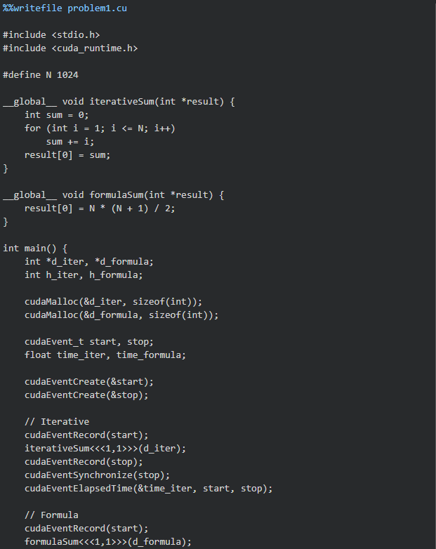

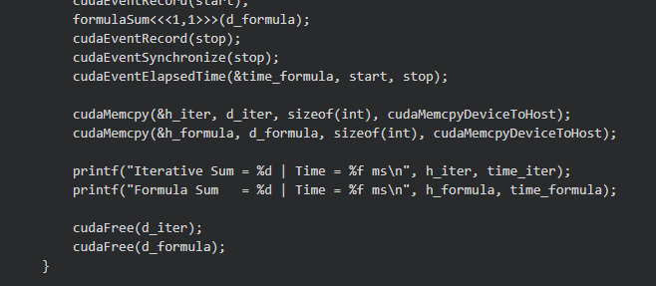
OUTPUT
Iterative Sum = 524800 | Time = 12.496864 ms
Formula Sum = 524800 | Time = 0.017568 ms

INTERPRETATION
Both methods produce the same result (524800), confirming correctness of the implementation.
However, there is a significant difference in execution time. The iterative approach takes 12.50 ms, while the formula-based approach takes only 0.018 ms, making it dramatically faster.
This large difference occurs because the iterative method performs multiple operations (looping from 1 to N), whereas the formula computes the result in a single arithmetic operation, reducing computational overhead.
The results demonstrate that algorithm choice has a major impact on performance, even when executed on a GPU. In this case, the problem is not limited by parallelism but by the efficiency of the computation itself.

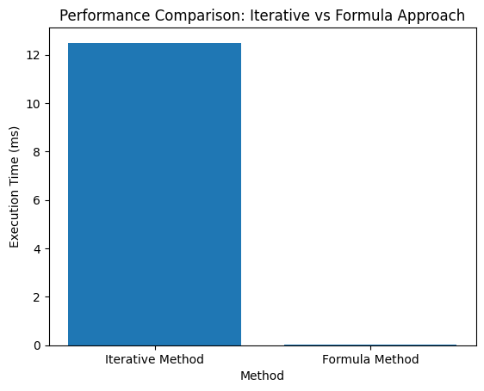

PROBLEM 2
CODE
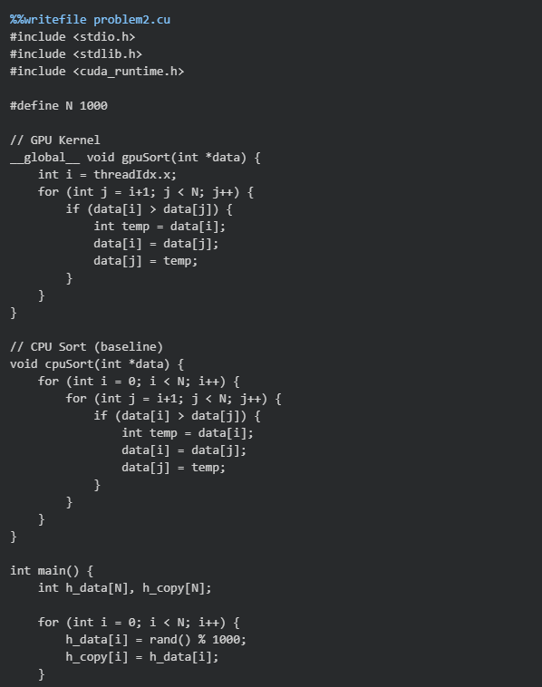
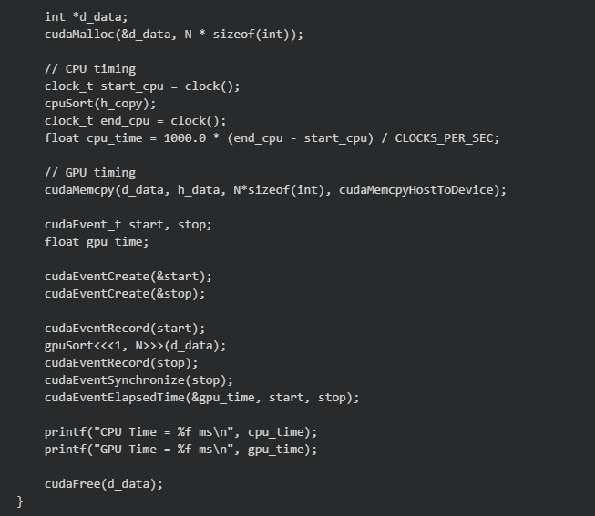
OUTPUT
CPU Time = 2.988000 ms
GPU Time = 15.367008 ms

INTERPRETATION
The CPU execution time is 2.99 ms, while the GPU execution time is 15.37 ms, indicating that the CPU performs significantly faster than the GPU for this task.
This result shows that the implemented GPU sorting approach is less efficient than the CPU version. The main reason is that the algorithm used is not well-suited for parallel execution. The kernel likely involves sequential dependencies and inefficient memory access patterns, which limit the benefits of GPU parallelism.
Additionally, the overhead of kernel launch and data transfer in GPU execution contributes to the increased execution time, especially for relatively small input sizes (n = 1000).
Overall, this demonstrates that GPUs do not always outperform CPUs, particularly when the algorithm is not optimized for parallel execution or when the problem size is small.

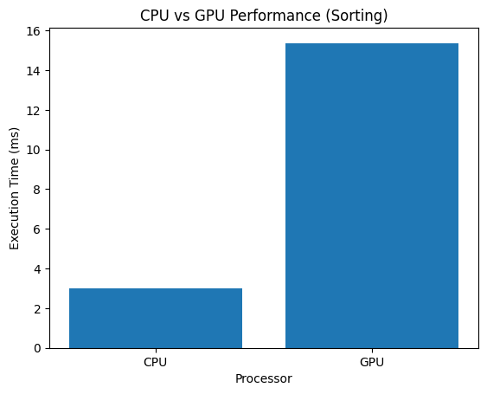

PROBLEM 3
CODE
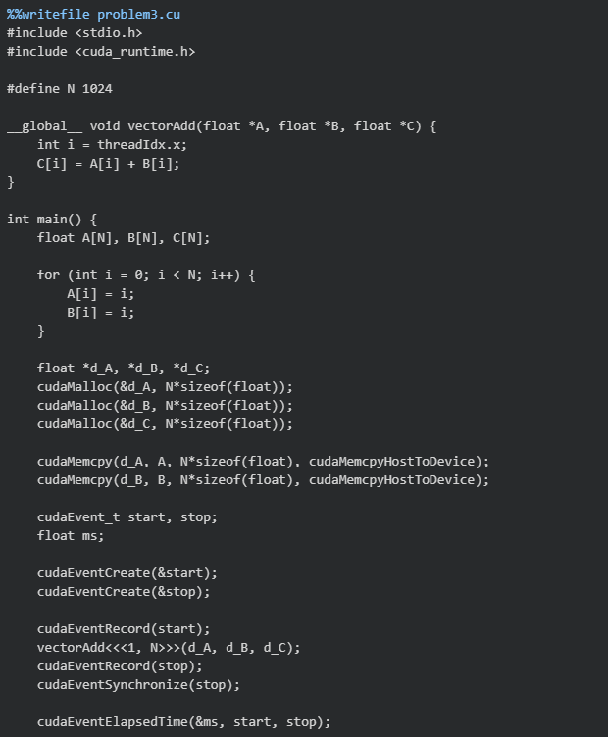
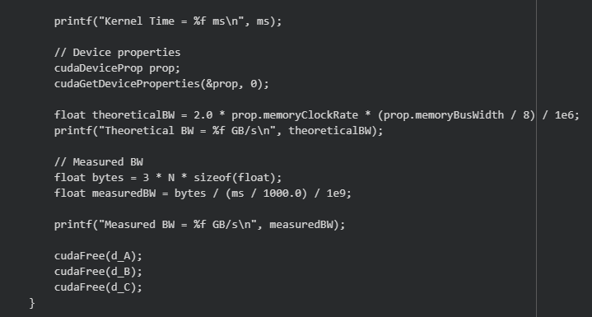

OUTPUT
Kernel Time = 11.917696 ms
Theoretical BW = 320.063995 GB/s
Measured BW = 0.001031 GB/s

INTERPRETATION
The kernel execution time is 11.92 ms, indicating moderate execution speed for the vector addition operation.
The theoretical memory bandwidth of the GPU is 320.06 GB/s, while the measured bandwidth is only 0.00103 GB/s, which is extremely low in comparison. This large gap shows that the GPU resources are poorly utilized in this implementation.
The low measured bandwidth is mainly due to the small problem size (N = 1024) and the overhead associated with kernel launch and memory operations. Since vector addition is a simple operation with low computational intensity, performance is heavily dependent on memory access efficiency.
Overall, the kernel is memory-bound, but due to inefficient utilization and overhead, it achieves only a tiny fraction of the theoretical performance.
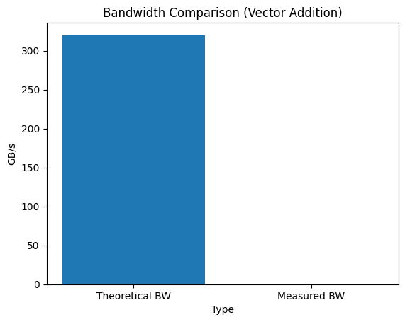
The graph shows a large gap between theoretical and measured bandwidth. While the GPU is capable of achieving up to 320 GB/s, the actual performance is extremely low (~0.001 GB/s). This indicates poor utilization of GPU resources due to small input size and overhead-dominated execution.

CONCLUSION
The experiments conducted in this assignment demonstrate that GPU performance is highly dependent on algorithm design, parallelization strategy, and memory utilization.
In Problem 1, both iterative and formula-based approaches produced correct results, but the formula-based method was significantly faster. This highlights that algorithm efficiency plays a critical role, even in parallel computing environments.
In Problem 2, the CPU outperformed the GPU, showing that not all algorithms benefit from GPU execution. Inefficient parallelization, sequential dependencies, and overhead can make GPU execution slower than CPU for small or poorly structured problems.
In Problem 3, the measured memory bandwidth was extremely low compared to the theoretical bandwidth. This demonstrates that memory access patterns and problem size strongly influence performance, and that achieving theoretical performance requires careful optimization.
Overall, it is illustrated that while GPUs offer high theoretical performance, actual performance depends on efficient use of parallelism, optimized algorithms, and effective memory management.

